**TALLER NUMERO 2 (MOLECULAS Y CAMBIOS DE ESTADO DE LA MATERIA)**

**TECHAR NAFFY LIZETH URREGO PRIETO**

**AREA DE QUIMICA GRADO SEXTO**

**2016**

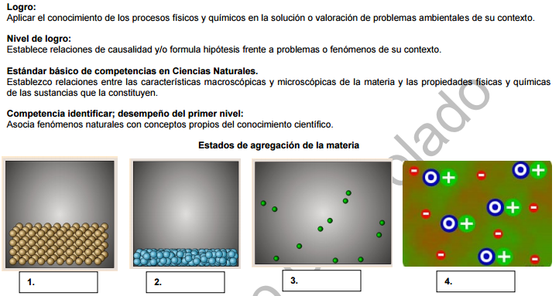

Describe cada imagen y clasifica que estado de ls materia corresponde cada imagen

1. ________________________________________________________________________________________________________________________________________________________________________________________________________________________________________________________________________________________________________
2. ________________________________________________________________________________________________________________________________________________________________________________________________________________________________________________________________________________________________________
3. ________________________________________________________________________________________________________________________________________________________________________________________________________________________________________________________________________________________________________
4. ________________________________________________________________________________________________________________________________________________________________________________________________________________________________________________________________________________________________________

